**Proof #24**

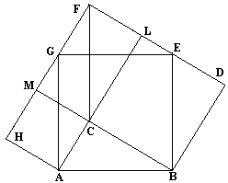

[***[Swetz](http://www.cut-the-knot.org/pythagoras/" \l "five)***] ascribes this proof to abu' l'Hasan Thâbit ibn Qurra Marwân al'Harrani (826-901). It's the second of the proofs given by Thâbit ibn Qurra. The first one is essentially the #2 above.

The proof resembles part 3 from proof #12. ΔABC = ΔFLC = ΔFMC = ΔBED = ΔAGH = ΔFGE. On one hand, the area of the shape ABDFH equals AC² + BC² + Area(ΔABC + ΔFMC + ΔFLC). On the other hand, Area(ABDFH) = AB² + Area(ΔBED + ΔFGE + ΔAGH).

Thâbit ibn Qurra's admits a natural generalization to a [***proof of the Law of Cosines***](http://www.cut-the-knot.org/Curriculum/Geometry/CosineLaw.shtml).

A [***dynamic illustration***](http://www.cut-the-knot.org/pythagoras/Pyth69PWW.shtml) of ibn Qurra's proof is also available.

http://cdn-6.cut-the-knot.org/gifs/tbow_sh.gif

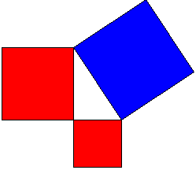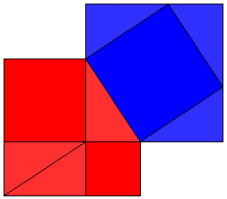

This is an "unfolded" variant of the above proof. Two pentagonal regions - the red and the blue - are obviously equal and leave the same area upon removal of three equal triangles from each.

# Pythagorean Theorem by Homothetic Copies (Proof 41)

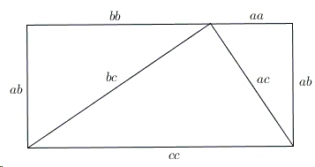

This one was sent to me by Geoffrey Margrave from Lucent Technologies. It looks very much as[***#8***](http://www.cut-the-knot.org/pythagoras/index.shtml#8), but is arrived at in a different way. Create 3 scaled copies of the triangle with sides a, b, c by multiplying it by a, b, and c in turn. Put together, the three similar triangles thus obtained to form a rectangle whose upper side is a² + b², whereas the lower side is c². (Which also shows that #8 might have been concluded in a shorter way.)